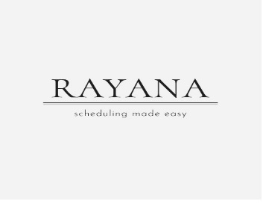
Price list

Universal calendar (2025):
Pen calendar: 999.opkr
The Universal Company Calendar 2025 is a specific office calendar designed by Universal, a well-established brand that offers a wide range of office supplies. Typically, Universal's calendars are known for their practicality, simple design, and functionality, making them a popular choice for businesses and personal use.
IN VERY AFFORDABLE PRIZES;
DISCOUNTED RATE ONLY WEEKLY OFFER
